Marketing Campaign Analysis Report

Introduction
This data analysis will help in understanding customer buying behavior as well as the effectiveness of various marketing campaigns. By using the Marketing Campaign dataset, customer spending behavior, their channel preferences for making purchases, and reactions to marketing campaigns were studied in detail.
The findings obtained from the data analysis will be useful for the company to gain better understanding of their customers, products, and channels which have been more successful.

Data Cleaning and Preparation
The dataset contains 2,240 customer observations with 29 different variables including demographics information, purchasing information, and marketing campaigns’ response information.
In preparation for the analysis, the data was cleaned and preprocessed as follows:
- Dataset structure was observed and data types were examined.
- Missing values were identified in the Income variable.
- Median income in the dataset was used to fill missing income values.
- Duplicates were checked and there was no duplication in the dataset.
- Dt_Customer variable was changed into datetime format.
- Total spending variable was created from all product category spendings.
After the preprocessing, the dataset was ready to be analyzed.

Exploratory Data Analysis
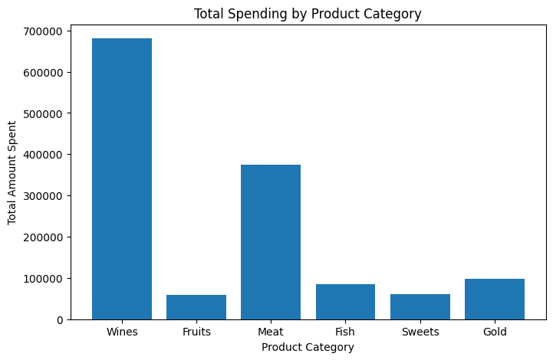
Total Spending by Product Category

Observations
- Wine products are ranked the highest in terms of expenditure.
- Meat products rank second in purchases.
- Fruits and sweets make the smallest contribution to the total expenditure.

Interpretation
The findings indicate that customers are more than ready to pay extra money for premium products like wine and meat. It is evident that these products generate the maximum revenue.

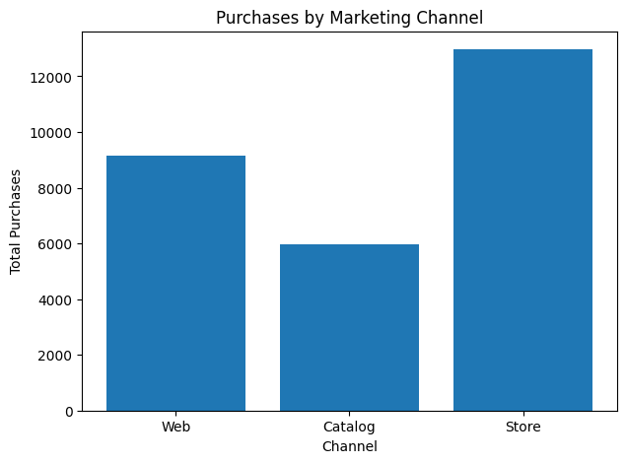
Purchases by Marketing Channel

Observations
- Majority of buying occurred at physical stores.
- Web buying still represents a high value and there appears to be a decent opportunity to drive this value for other channels to compete.
- Catalog buying has much smaller values than other channels.

Interpretation
Consumers continue to be comfortable buying through stores and the sales channel represents a significant portion of sales for the business. Similarly, the high value for Web buying shows a significant opportunity to leverage this channel for marketing and selling.

Campaign Acceptance Analysis
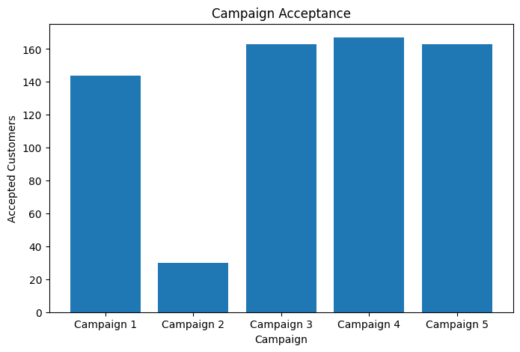
Observations
- Campaign 4 has the highest acceptance rate.
- Campaign 3 and 5 also have a decent acceptance rate.
- Campaign 2 has the lowest acceptance rate of all campaigns.

Interpretation
Not all of the campaigns drew the same attention from customers. We might be able to learn something from the way Campaign 4 was carried out, while trying to find out why Campaign 2 performed so badly.

Response to Latest Campaign
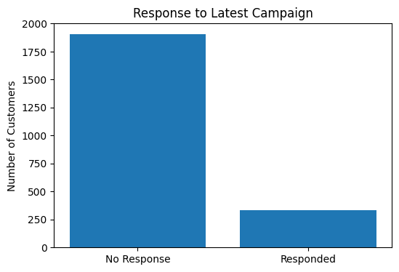

Observations
- The customers failed to react to the recent marketing campaign;
- Less than 20% of customers had a positive response to the latest campaign. This shows there is a lot of room to improve campaign targeting and customer engagement.
Interpretation
This poor reaction by the customers may be due to the fact that the campaign was aimed at the wrong customer segments or the offer was of no special interest to them. The next campaign may be better targeted and include individual offers for the customers.

Average Spending by Education Level
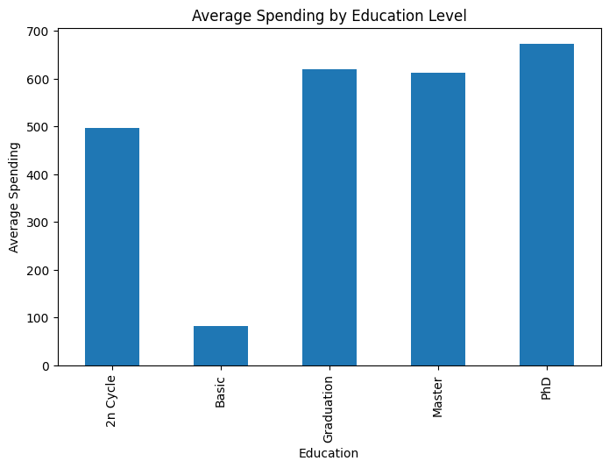

Observations
- Customers with PhD qualifications have the highest average spending.
- People with degrees after graduation and master’s degrees also spend a lot of money.
- Customers with Basic education have the lowest average spending.
Interpretation
It seems that how much money customers spend is related to how education they have. PhD customers and customers with graduation and master’s degrees spend money because they have higher education so they are good targets, for expensive products and special advertising. Customers with higher educational qualifications represent a valuable segment for premium products and targeted marketing campaigns.

Recommendations
Based on the findings from the analysis, the following recommendations can be considered:
- Increase marketing investment in wine and meat products since they generate the highest customer spending and contribute significantly to overall revenue.
- Continue investing in store-based marketing while also strengthening online sales and digital marketing initiatives.
- Study the factors that contributed to the success of Campaign 4 and apply similar approaches in future campaigns.
- Re-evaluate Campaign 2 to understand why customer acceptance was low and identify areas for improvement.
- Develop targeted campaigns for high-spending customer groups, particularly those with higher educational qualifications.
- Use customer segmentation and personalized offers to improve campaign response rates.
Conclusion
This exploratory data analysis proved extremely insightful, providing us with some deep insights about our customers’ buying behavior as well as how successful/unsuccessful were our marketing campaigns. We came to know that wine & meat are the product categories where we get the most amount of money spent by our customers, hence are the ones contributing the most to our revenues. However, physical stores still seem to be our customers’ favorite place from where they prefer buying (although Web presents a great opportunity).
Our campaign analysis revealed mixed results – while Campaign 4 received the highest acceptances, Campaign 2 turned out to be the worst performer. Furthermore, people with higher education degree tend to spend more, which also turns out to be a good targetable customer segment for us.
Based on these insights, what the company could do next is to promote its high performing products, strengthen their offline and online sales channels and come up with much more personalized marketing strategies to make their campaigns more effective and engaging to their customers.

